**Analysis of the most impactable factor for engine start**

**Step1: Built the model of all factors**

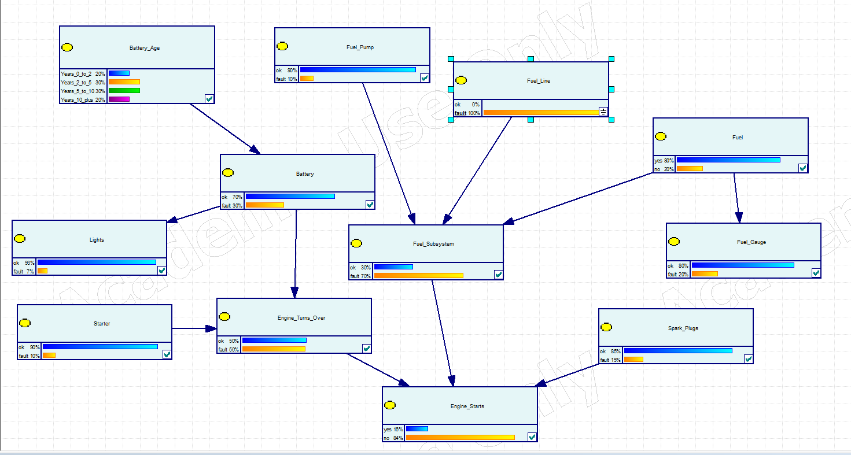

**Step2: Overview of the relationship:**

* all factors with positive impact to the result, which means ok results yes, fault results No.
* we have three direct factors and 6 independent which are indirect factors.
* Run with known probability: the engine status is 31% for yes, 69%for no.

**Step3: Start with closest comparing:**

1. **Compare the** **closest factors**

Every time, Only change one of factor to be 100% fault or 100% ok and the Engine_Status result:

|  |  |  |  |
| --- | --- | --- | --- |
| To be 100% | Engine_Turn_over | Fuel_Subsystem | Spark_Plugs |
| Yes(ok) | 54% | 44% | 35% |
| No(fault) | 92% | 96% | 93% |

From this table we can see,

Fuel_Subsystem is an important factor since when it becomes fault, the result has the most percentage 96% to be NO.

Engine_Turn_over is also an important since when keep it ok, the result would be 54% to be YES.

Compare the Fuel_Subsystem and Engine_Turn_over:

If Engine_Turn_over is totally OK and Fuel_Subsystem is totally fault, No= 96%

If Fuel_Subsystem is totally OK and Engine_Turn_over is totally fault, No= 90%

We can see Fuel_Subsystem is a little bit impactable than Engine_Turn_over.

Compare again:

|  |  |  |  |
| --- | --- | --- | --- |
| Engine_Turn_over | Fuel_Subsystem | Spark_Plugs | engine status |
| Fault | ok | ok | 90% |
| ok | fault | ok | 95% |
| ok | ok | fault | 90% |

From this table we can see the most important factor is Fuel_Subsystem.

**Totally, the most important factor is Fuel_Subsystem.**

1. **See how the independent impact the result:**

**Check** **Fuel_Subsystem:**

Every time, Only change one of factor to be 100% fault or 100% ok and the Fuel_Subsystem:

|  |  |  |  |
| --- | --- | --- | --- |
| To be 100% | Fuel-Pump | Fuel_Line | Fuel |
| Yes(ok) | 72% | 71% | 83% |
| No(fault) | 77% | 70% | 100% |

From this table we can see: **Fuel would the most important factor. from Fuel_Subsystem**. If fuel_subsystem is fault, and the engine would be 96% NO.

1. **Check the** **Engine_Turn_Over**

|  |  |  |
| --- | --- | --- |
| To be 100% | Battery | Starter |
| Yes(ok) | 72% | 56% |
| No(fault) | 100% | 100% |

From this table we can see, either of them fault, Engine_Turn_Over would be fault, and the result would be 92% NO.

1. **Check Battery:**

Battery, the less year, the better.

1. **Check the independences:**

|  |  |  |  |  |
| --- | --- | --- | --- | --- |
| Result to be fault | starter | Batter age >10 years | Fuel | Spark Plug |
| 92% | Fault |  |  |  |
| 76% |  |  |  |  |
| 96% |  |  | Fault |  |
| 93% |  |  |  | Fault |

From this table we can see, **Fuel Gauge is the most impactable factors for engine start.**

**Conclusion:**

**Fuel is the most impactable factors for engine start.**

**And Fuel_Subsystem is the most important direct factor.**